**Auto Installation**

**for Legacy and UEFI by PXE server**

**Version 1.0**

**Version History**

|  |  |  |  |
| --- | --- | --- | --- |
| **Version** | **Date** | **Handled by** | **Comments** |
| V1.0 | 15-Oct-2019 | ZL Chen | First version release. |

System Structure: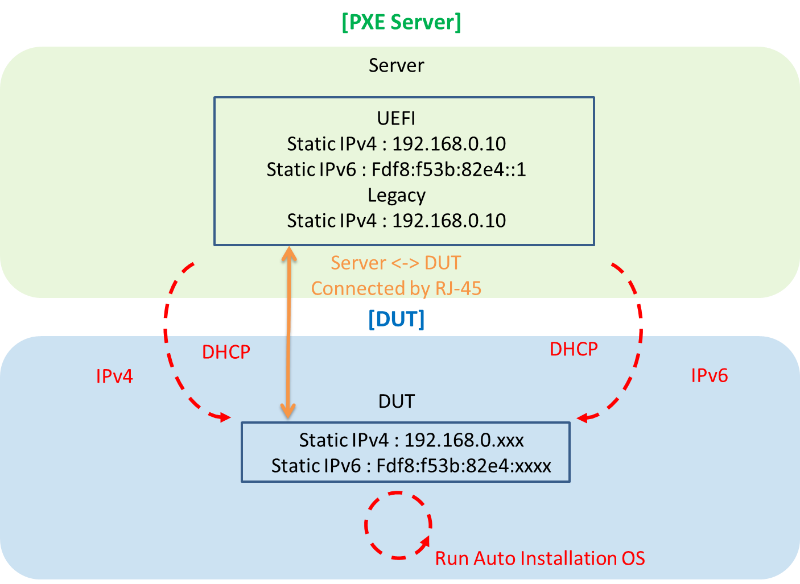

Precondition Setting:

Please make sure the DUT is connected with PXE Server.

Please follow the implement as below:

Step 1:

Please make sure the PXE server and DHCP server are launched.

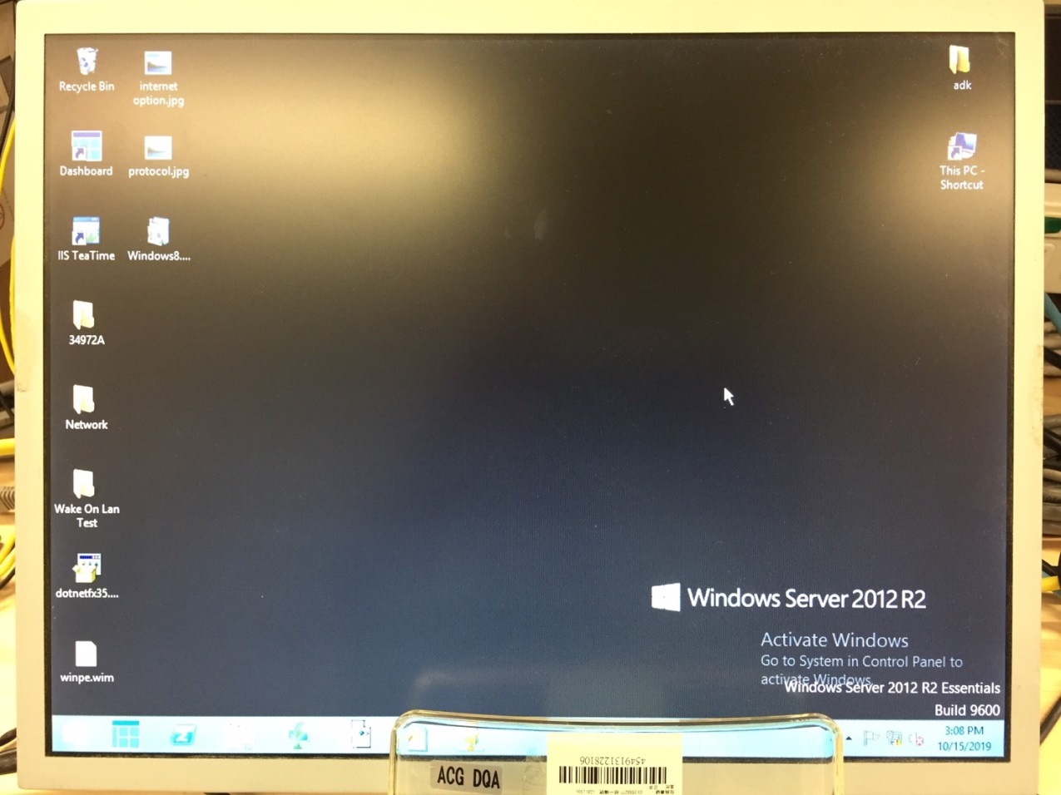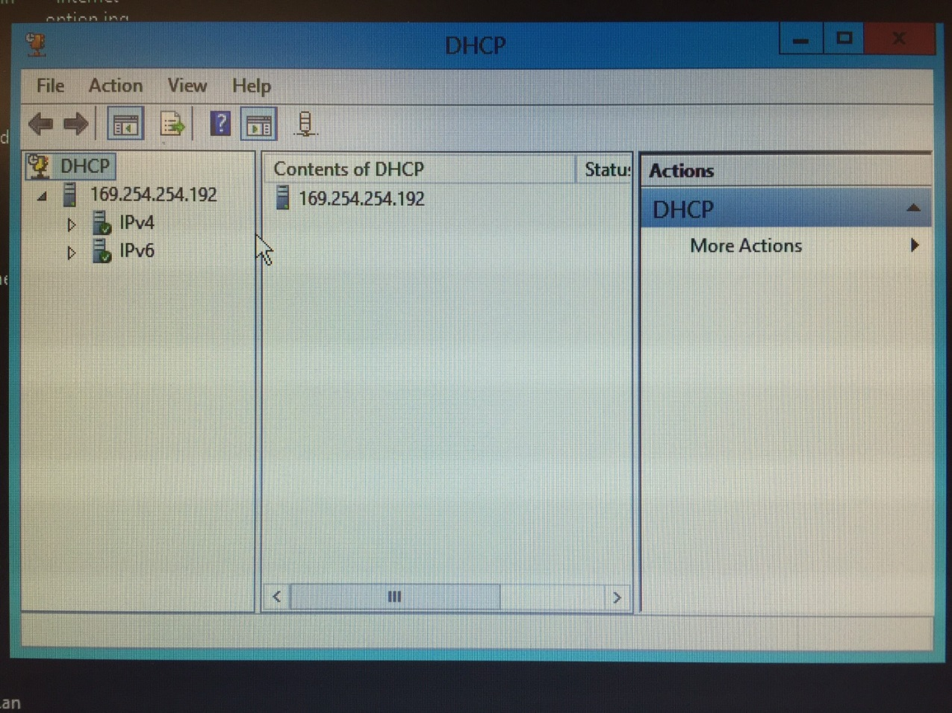

Step 2:

Launched the DUT’s computer, and login to the BIOS.

Make sure the auto installation you want.

|  |  |
| --- | --- |
| BIOS Setting | Auto Installation Operation System |
| Legacy | Windows 10 (64 bit) |
| Legacy | Windows 10 (32 bit) |
| UEFI | Windows 10 by IPv4 (64 bit) |
| UEFI | Windows 10 by IPv6 (64 bit) |

Please choose the Auto Installation method as below:

* Auto installation of Legacy base on Window 10 (64 bit).
* Auto installation of Legacy base on Window 10 (32 bit).
* Auto installation of UEFI base on Window 10 by IPv4 (64 bit).
* Auto installation of UEFI base on Window 10 by IPv6 (64 bit).
* Auto installation of Legacy base on Window 10 (64 bit).

Make sure the all of BIOS setting:

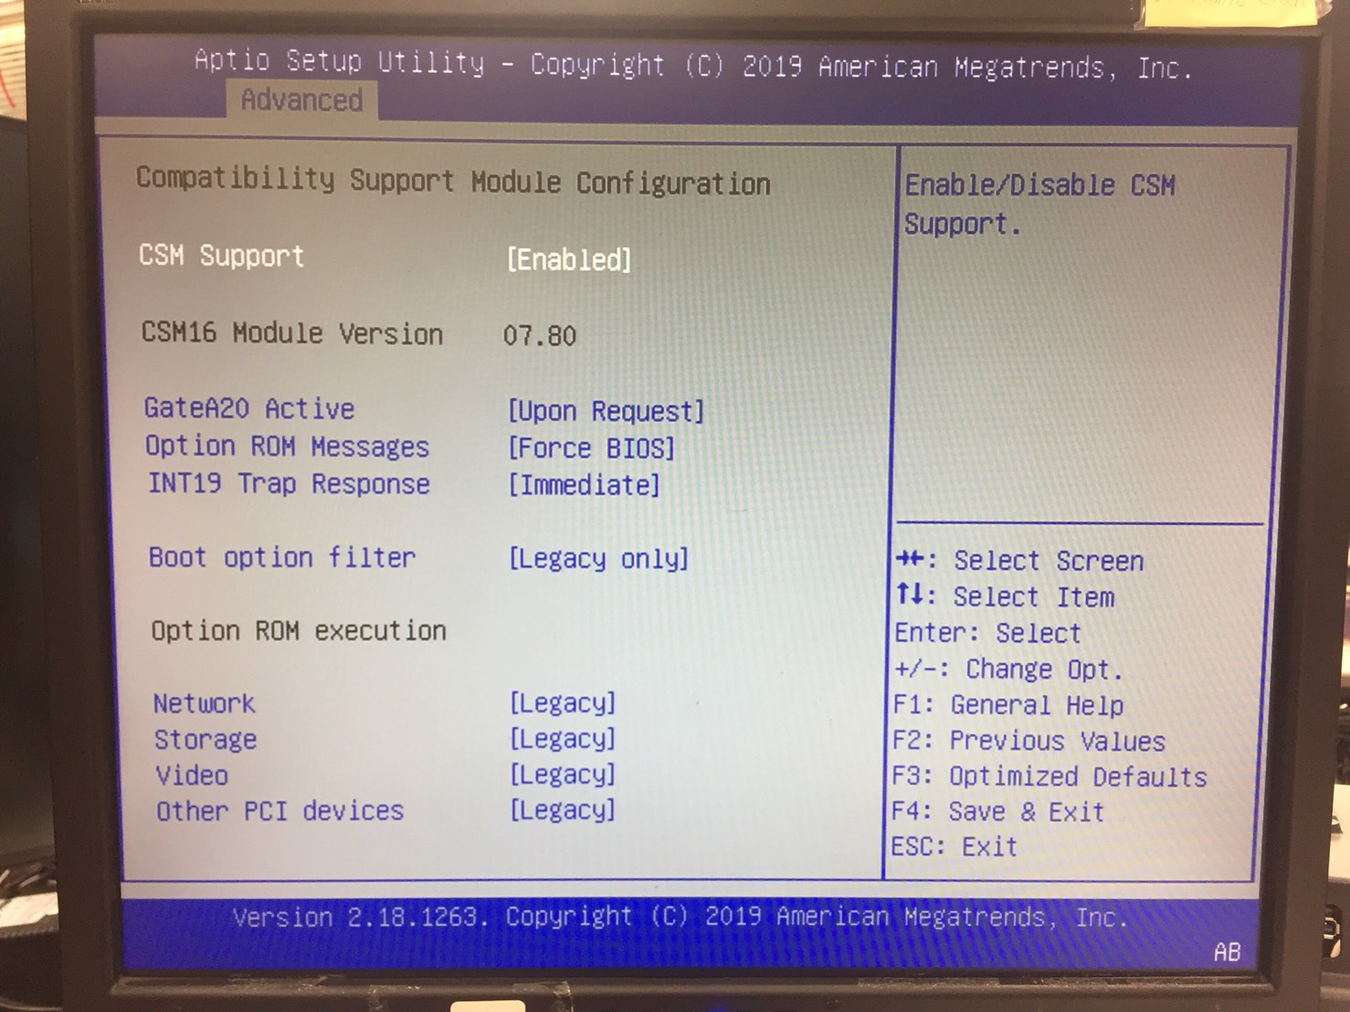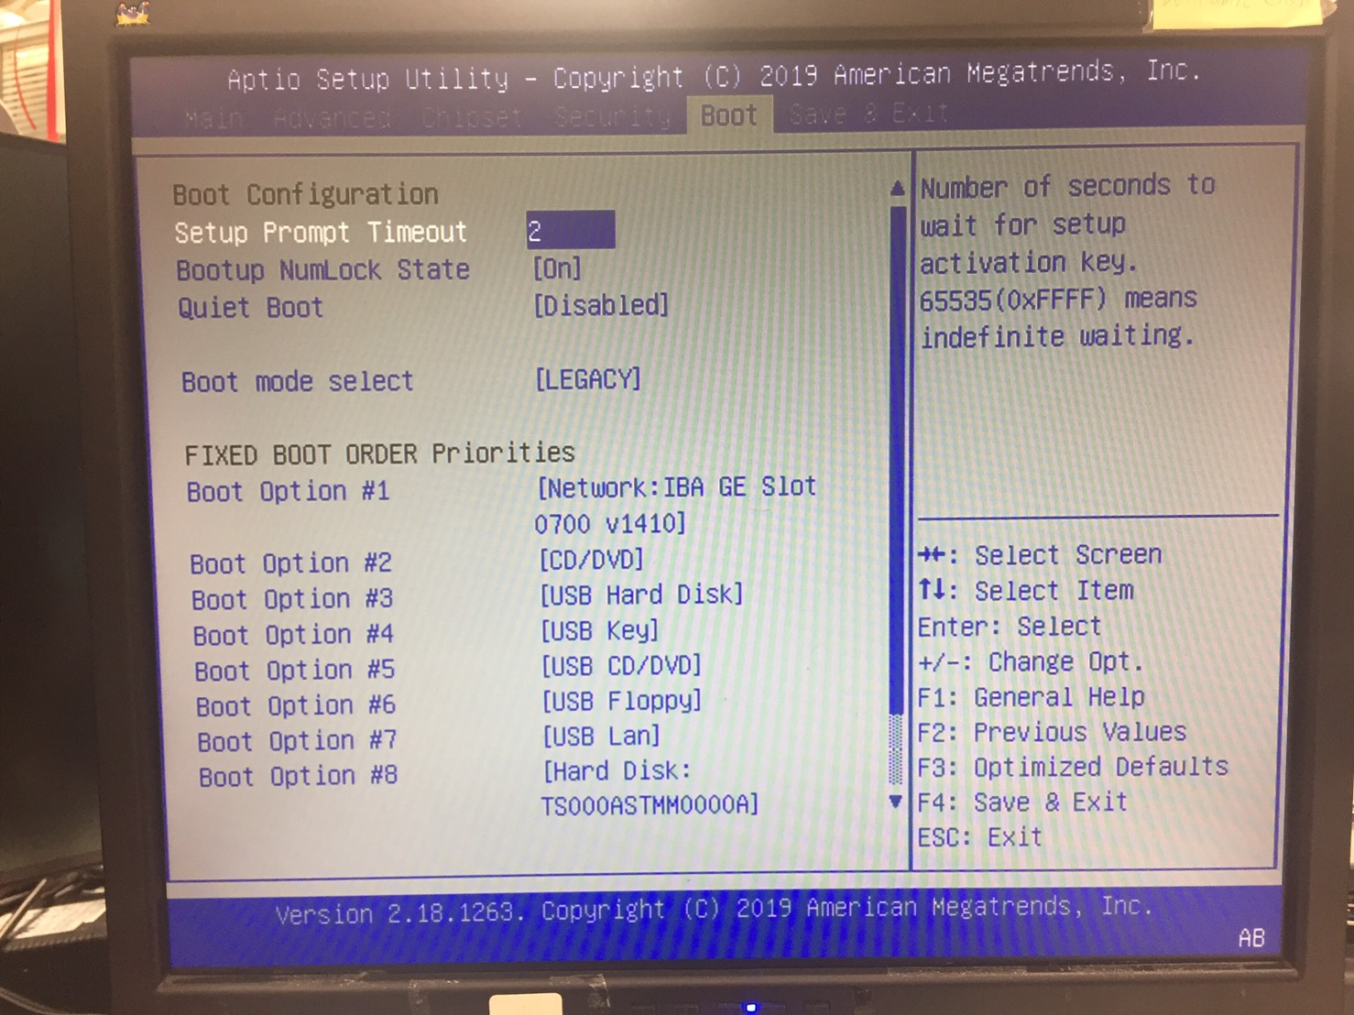

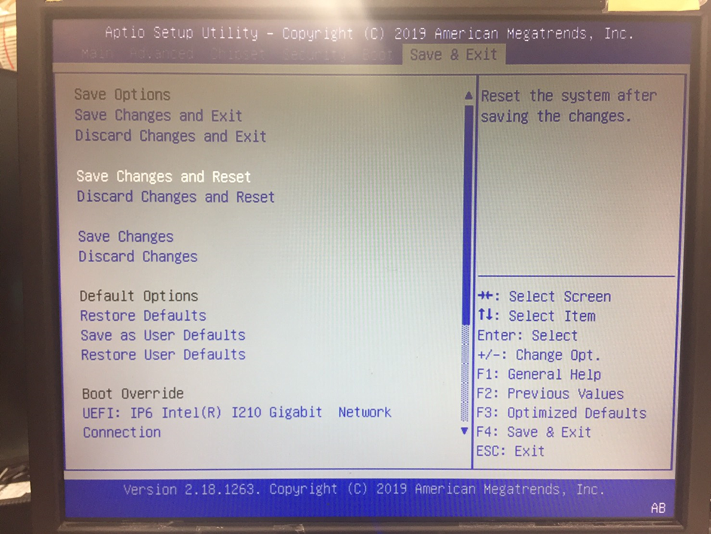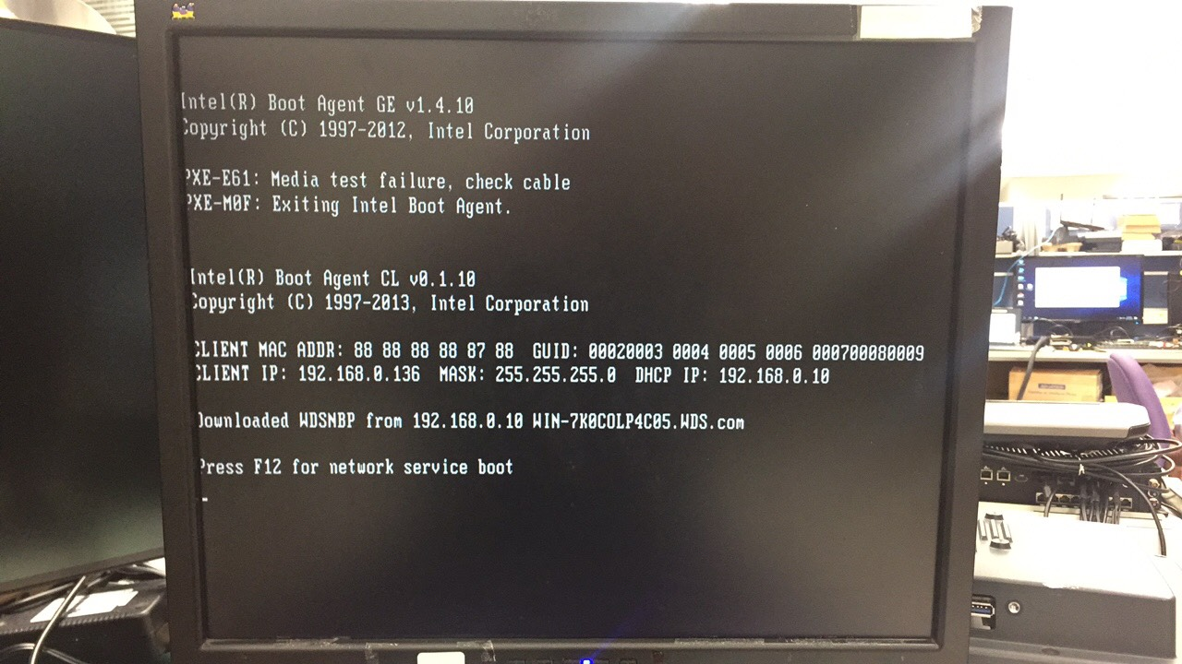Please tap the “F12” right now.

Select the “Windows 10 installation of Legacy (64 bit) (ZL)”, then “Enter”

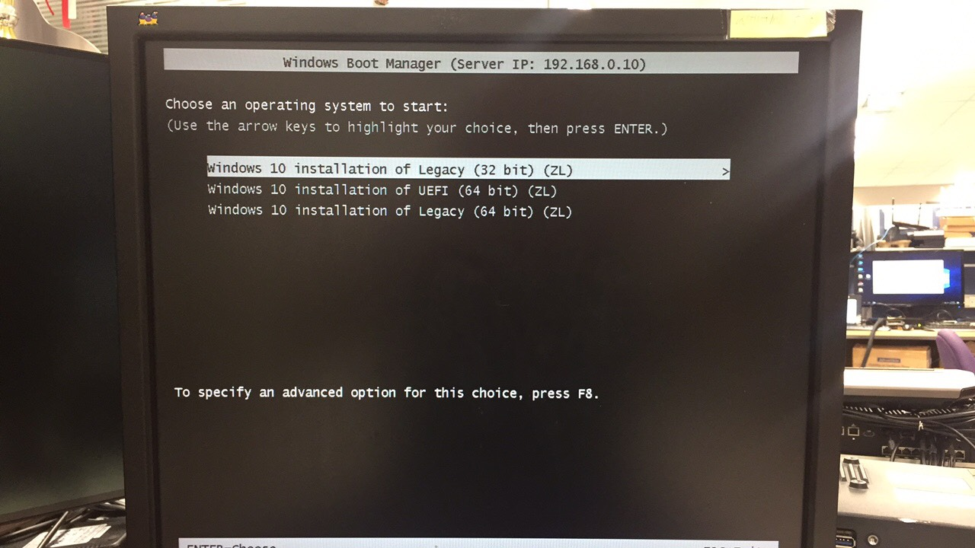

* Auto installation of Legacy base on Window 10 (32 bit).

Make sure the all of BIOS setting:



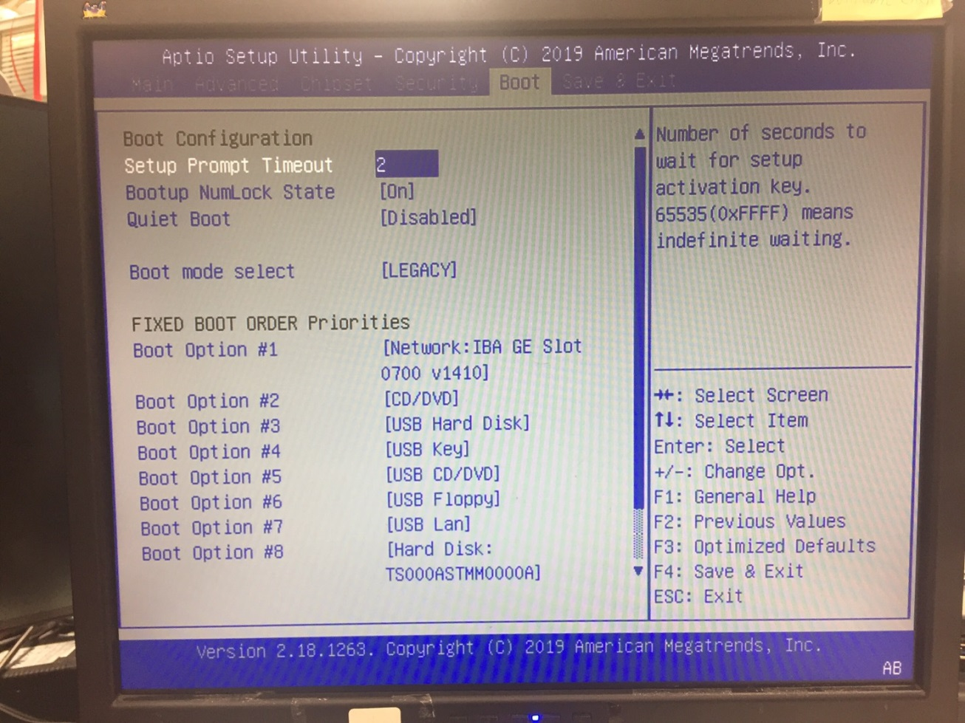



Please tap the “F12” right now.



Select the “Windows 10 installation of Legacy (32 bit) (ZL)”, then “Enter”



* Auto installation of UEFI base on Window 10 by IPv4 (64 bit).

Make sure the all of BIOS setting:

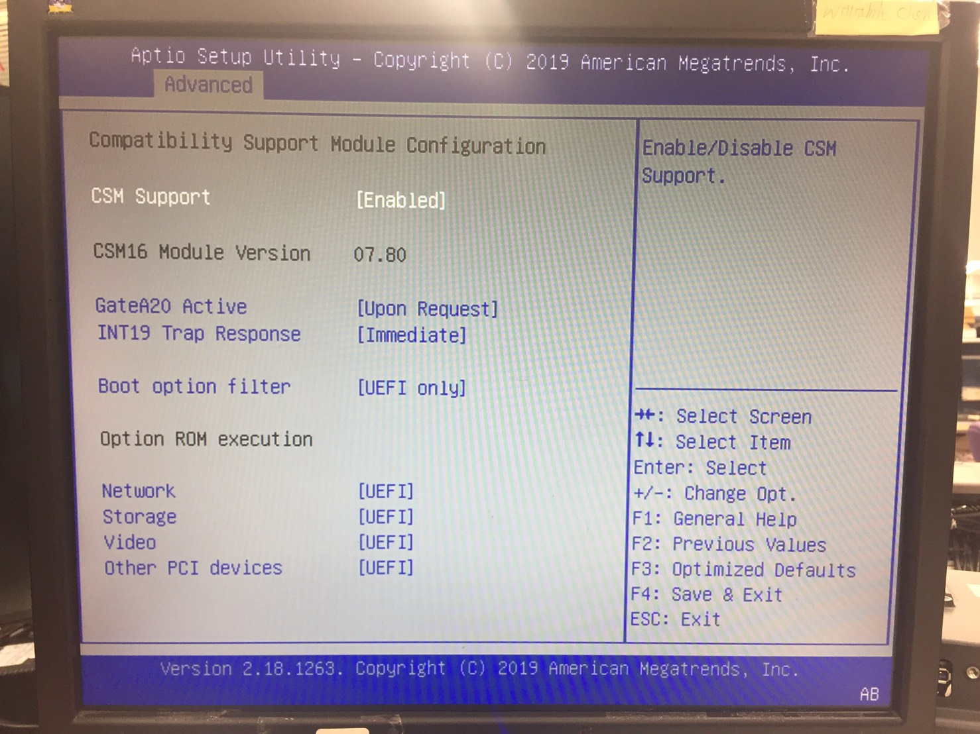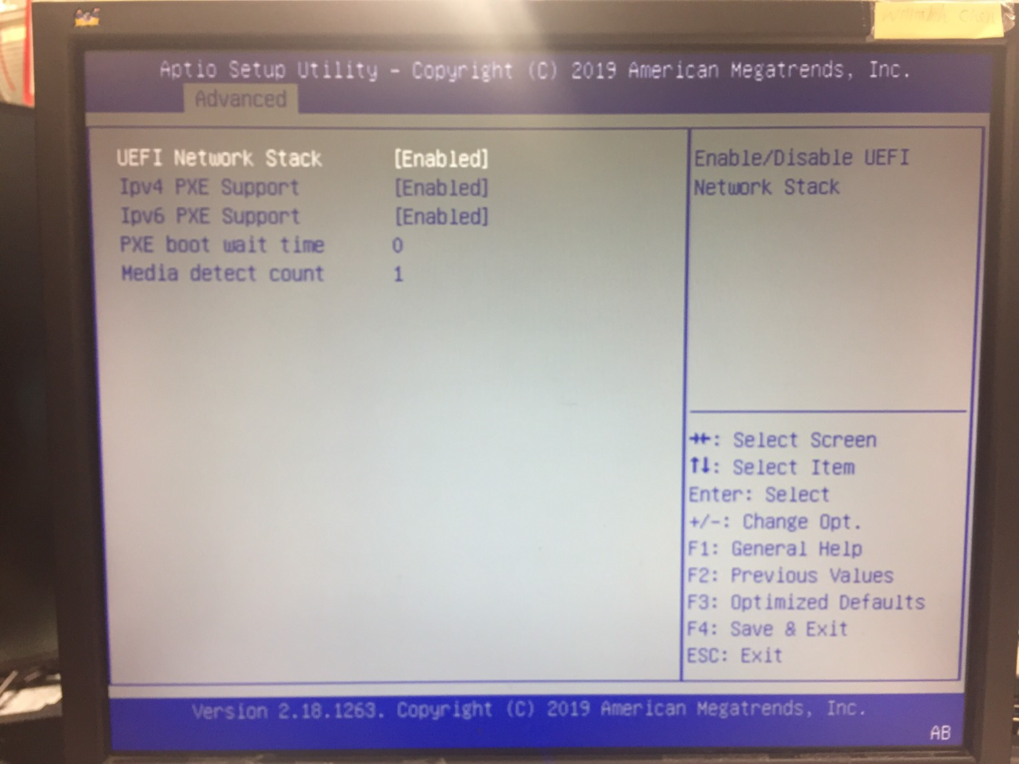

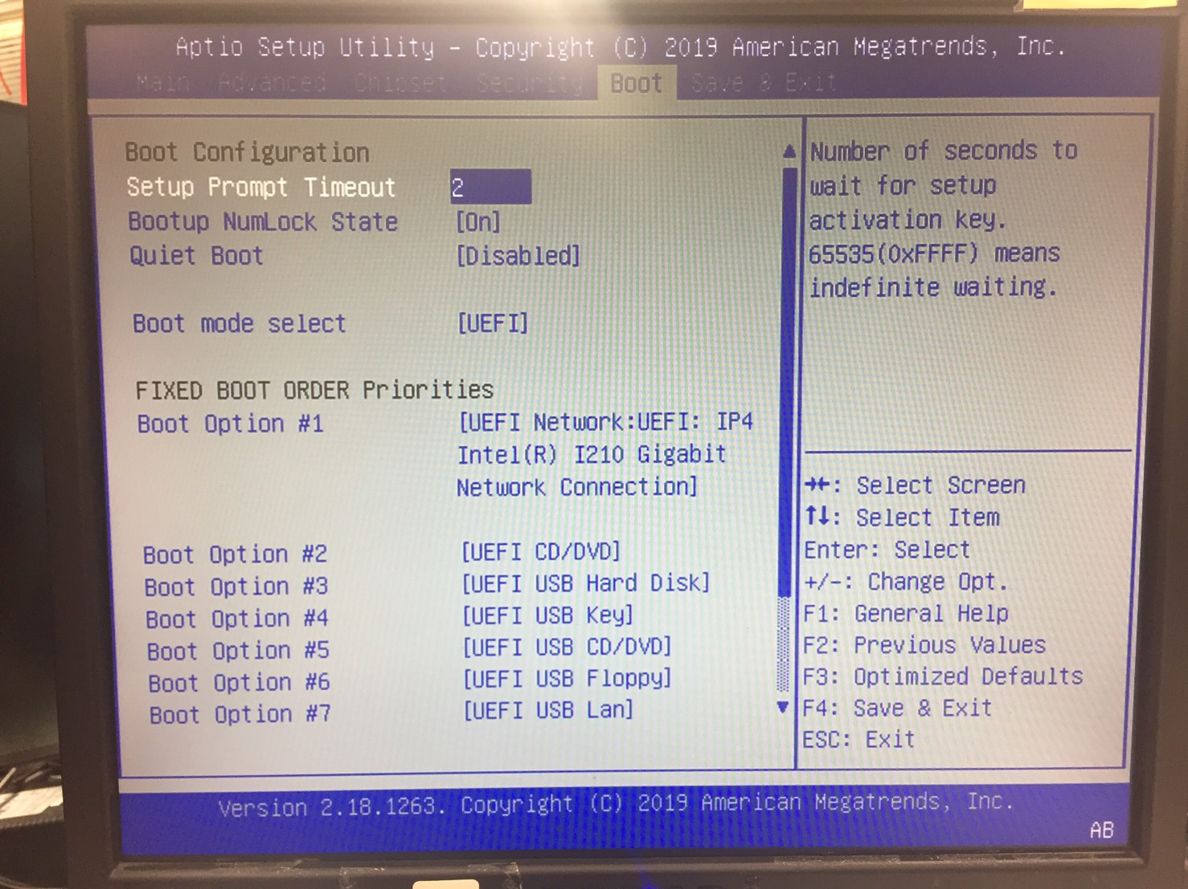

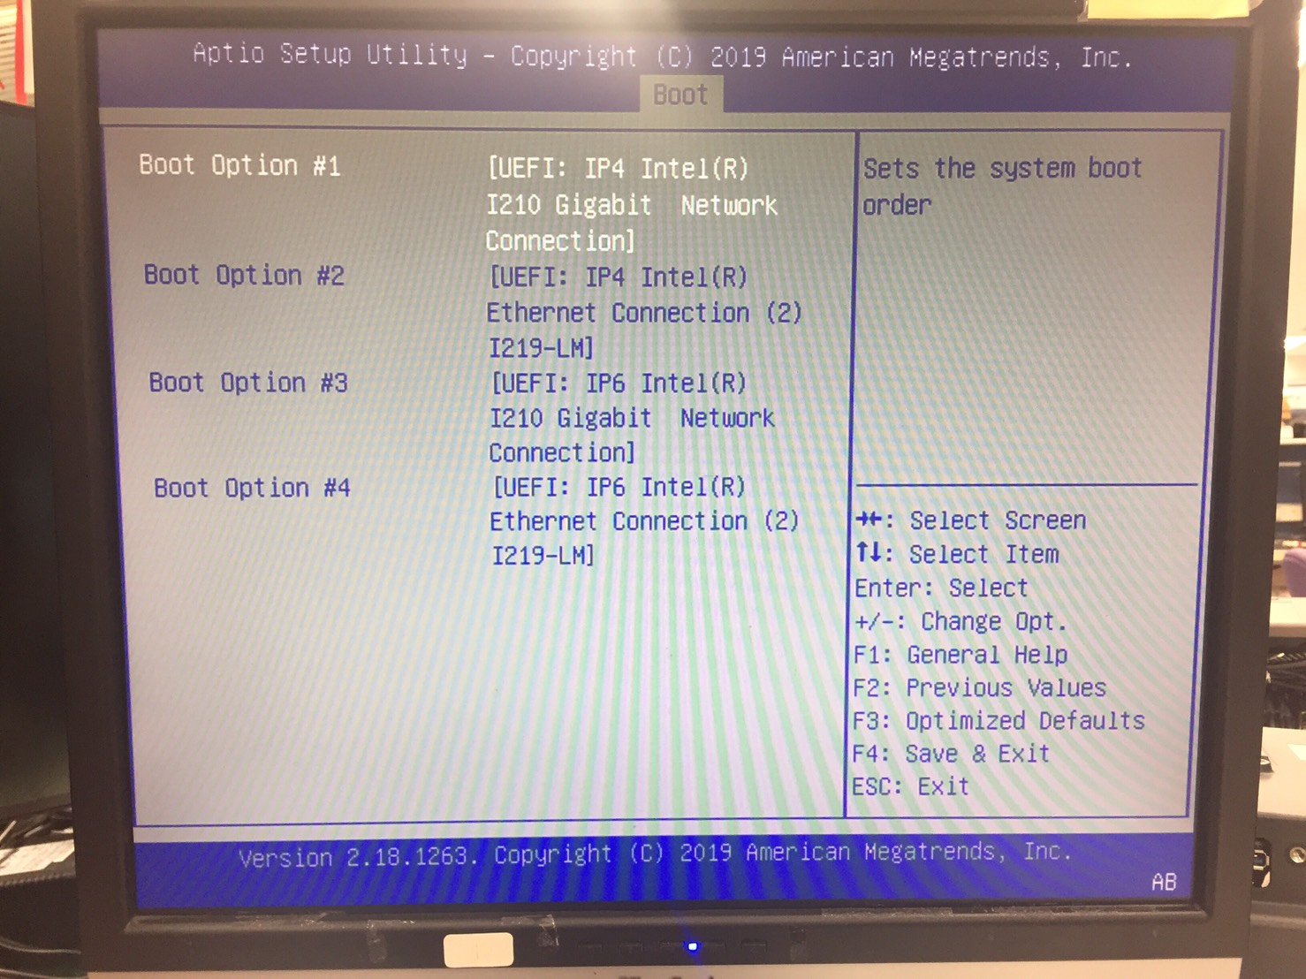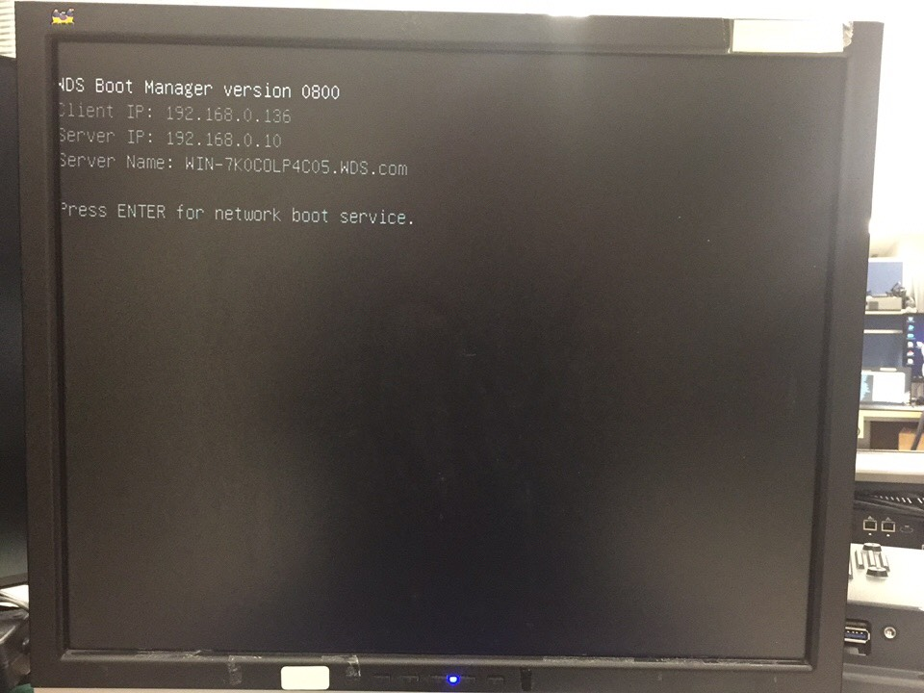

Please tap the “Enter” right now.

Select the “Windows 10 installation of UEFI (64 bit) (ZL)”, then “Enter”

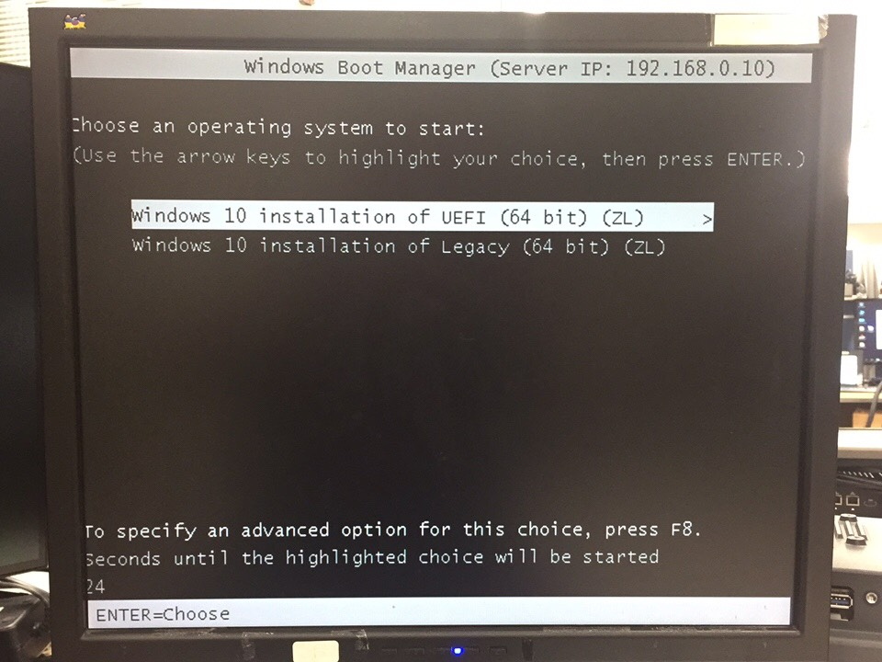

* Auto installation of UEFI base on Window 10 by IPv6 (64 bit).

Make sure the all of BIOS setting:



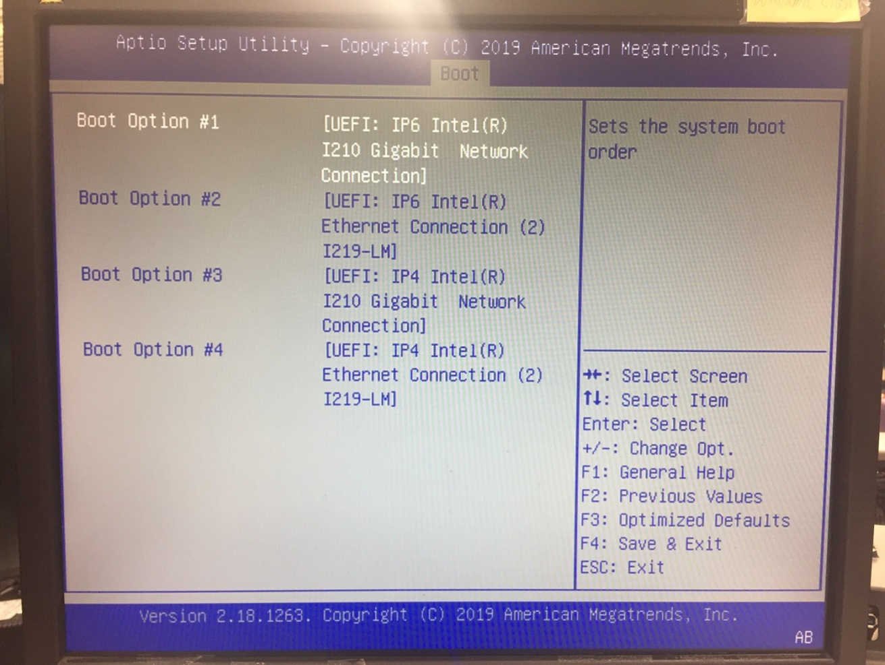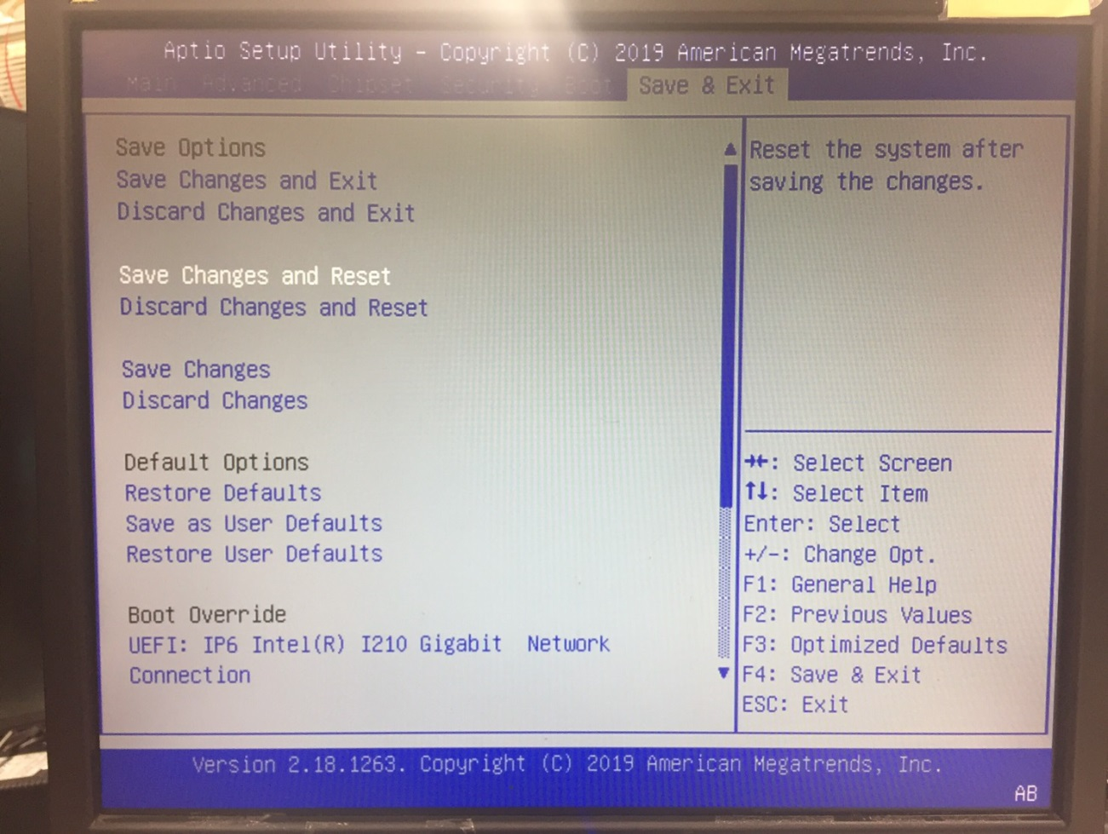

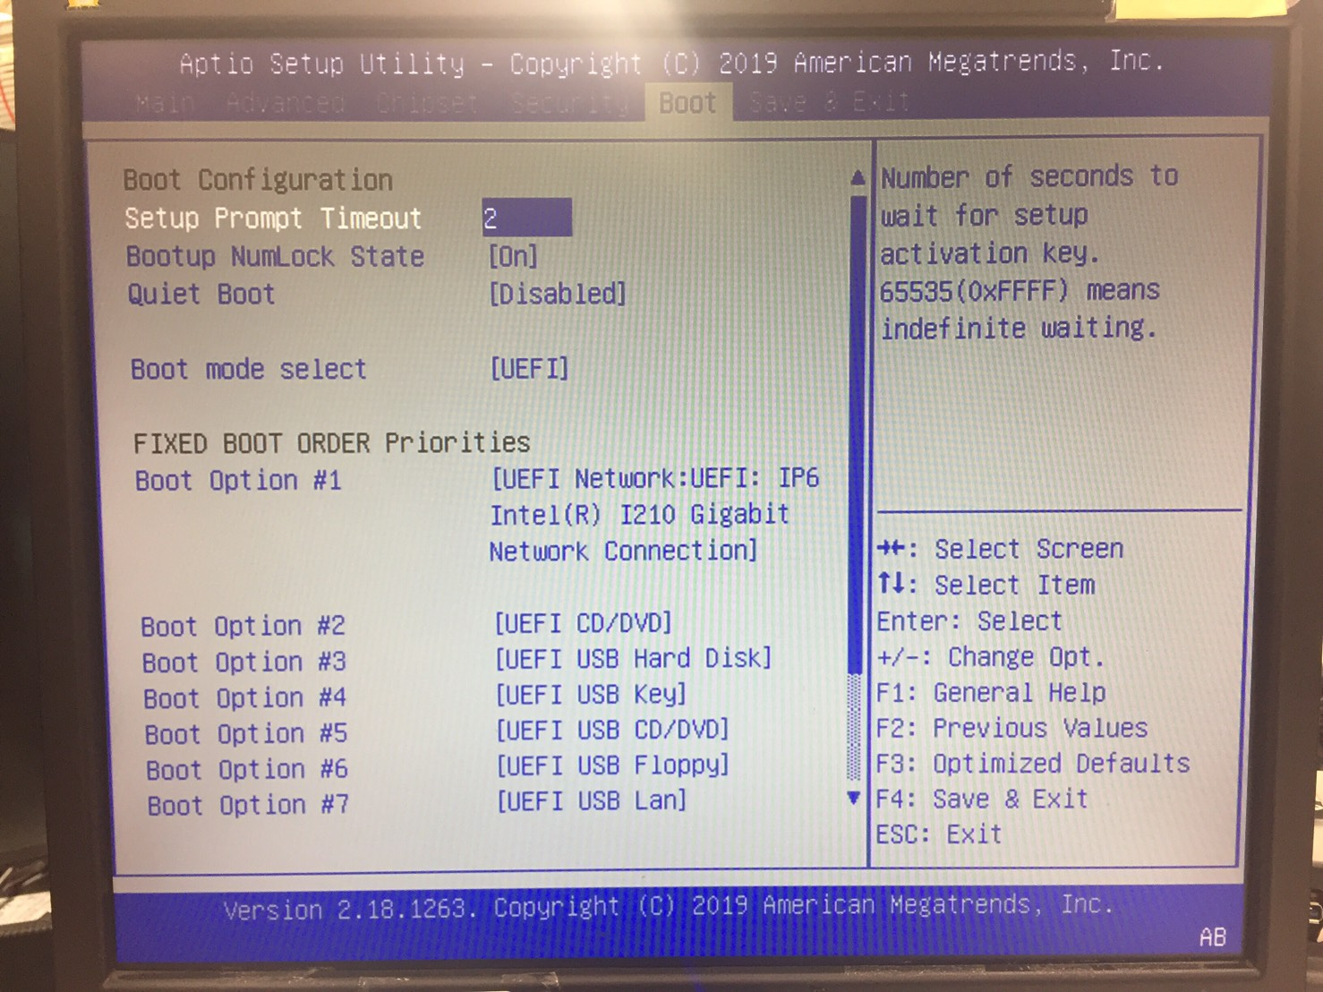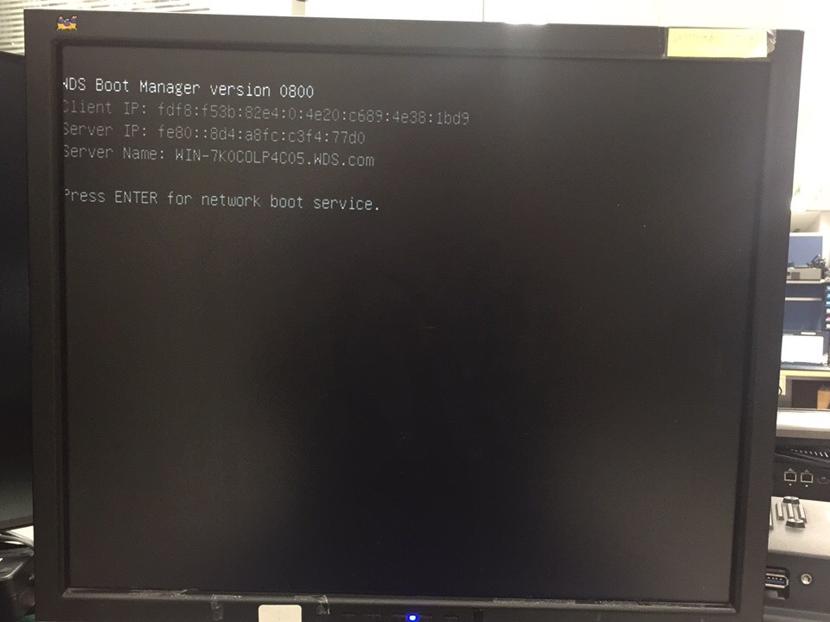

Please tap the “ENTER” right now.

Select the “Windows 10 installation of UEFI (64 bit) (ZL)”, then “Enter”



Step 3:

Auto Installation is executing. (Don’t touch anything)

